UNIT 5
Lesson 3 – PEOPLE IN MY NEIGHBOURHOOD

*Uputa za učitelja: Učenik ne rješava svih šest tekstova. Prema sposobnostima učenika odabrati jedan, dva ili tri teksta koji će učenici rješavati
( zadaci 1-6).

Lesson 3 – PEOPLE IN MY NEIGHBOURHOOD

- 1 a) Listen to your teacher read the text.
Poslušaj svog učitelja / učiteljicu kako čita tekst.
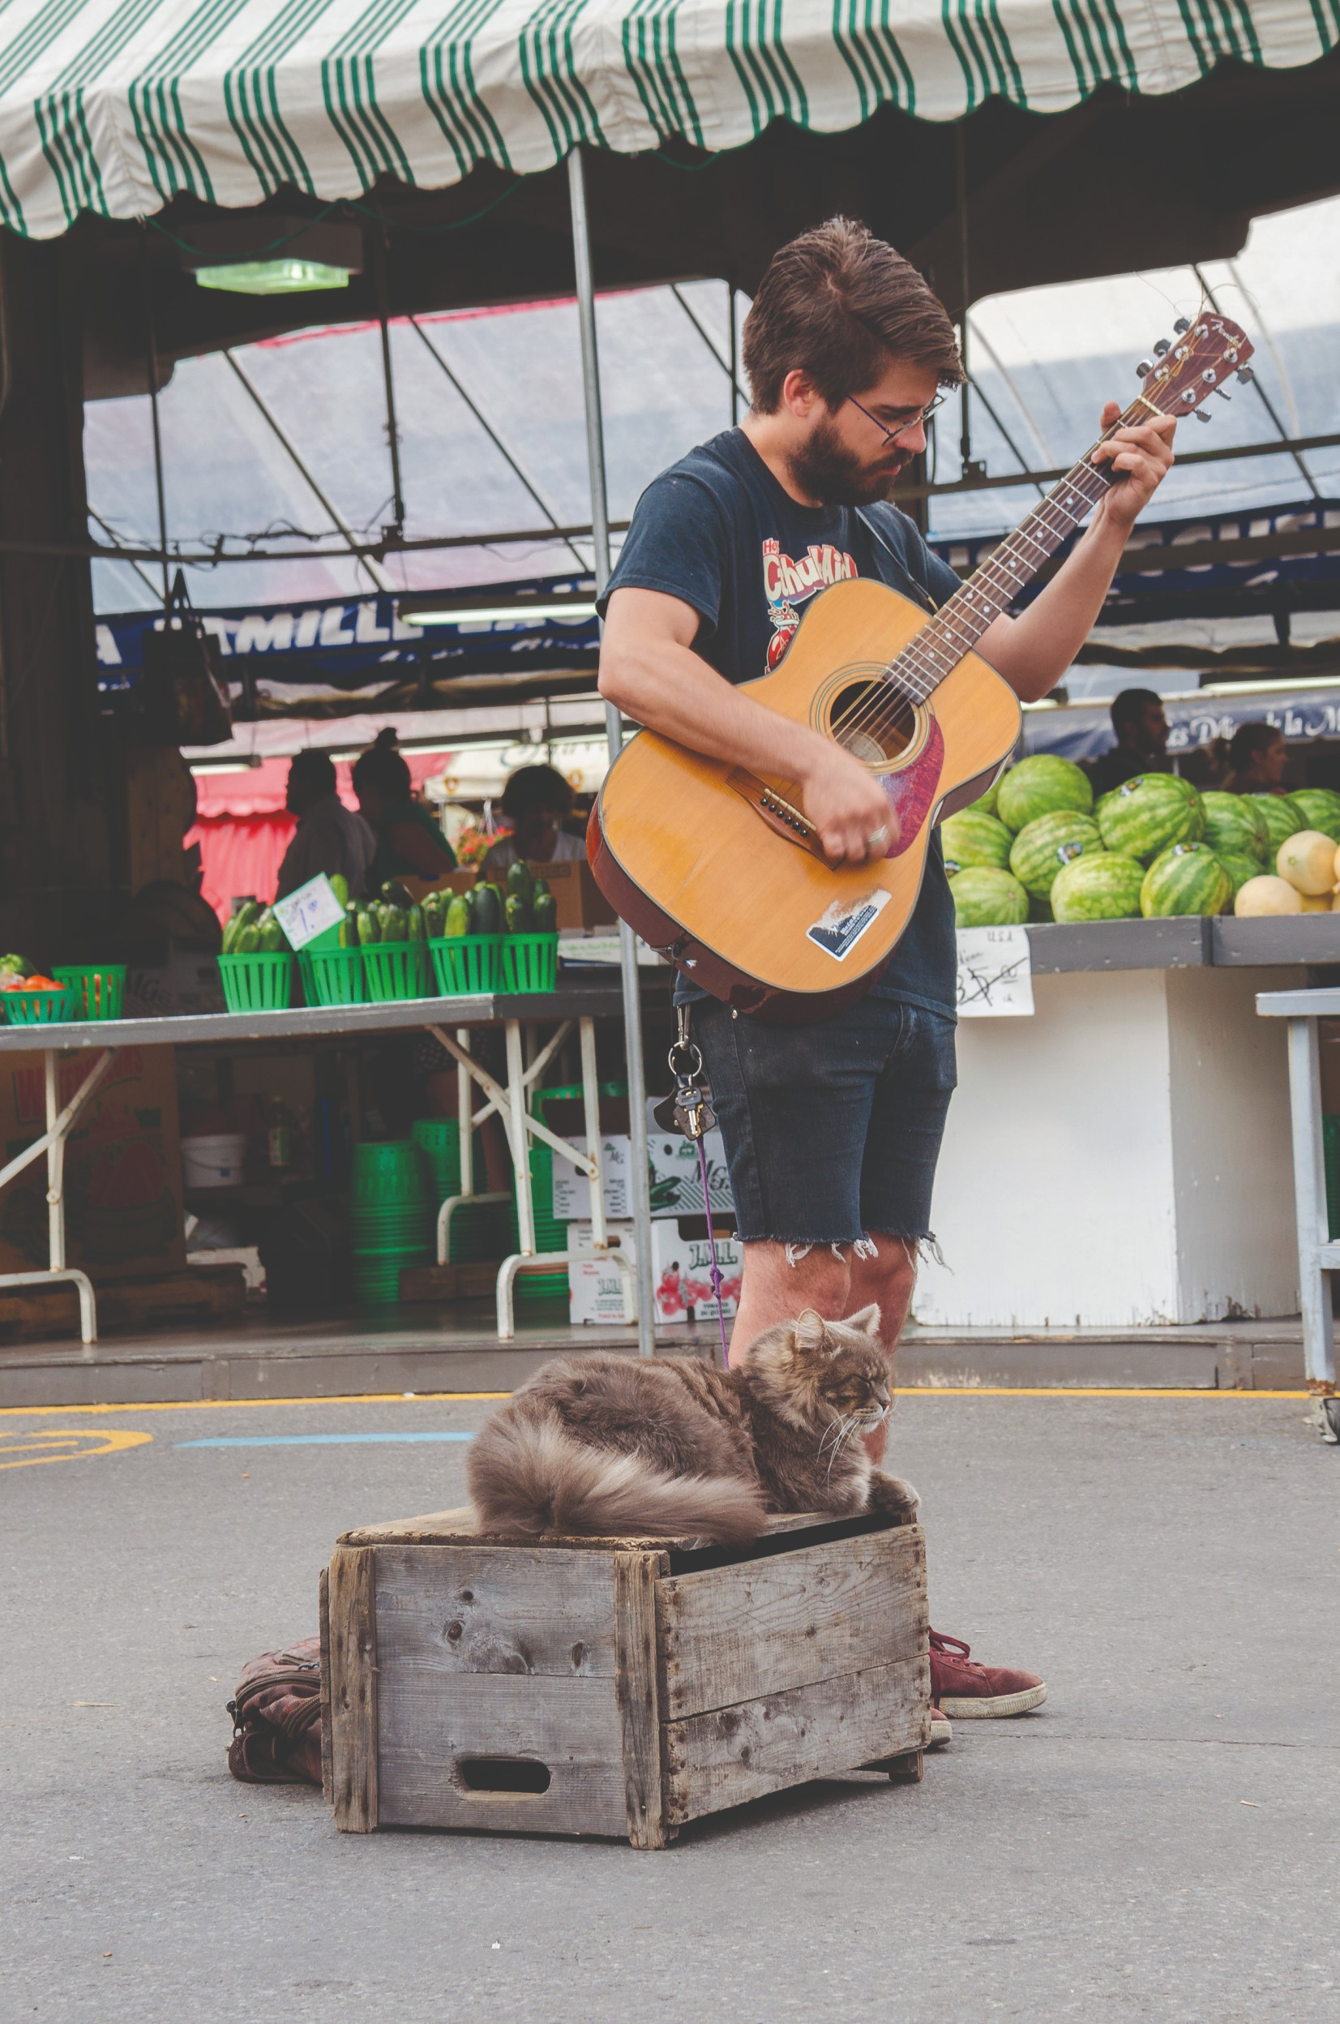

KEVIN

Kevin is a street musician.
Kevin je ulični svirač.

This is his favourite spot
Ovo je njegovo omiljeno mjesto za sviranje.
Look, he is playing the guitar. . 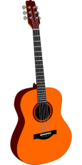
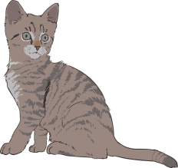
Sykes
Pogledaj, svira gitaru.

Sykes, his cat , is listening.
Skyes, njegova mačka, sluša.

Sykes is a very special cat
Skyes je vrlo poseba mačka.
It can meow to Kevin’s music.
MEOW!
Ona mijauče na njegovu muziku.

b) Read the text once again. Circle the correct answer.
Pročitaj tekst još jednom. Zaokruži točan odgovor.

1 Are Kevin and Skyes sitting in the park?
Sjede li Kevin i Skyes u parku?
Yes they are. / No, they aren't.
Da, oni sjede. / Ne, oni ne sjede.

2 Is Kevin playing the guitar?
Svira li Kevin gitaru?
Yes he is. / No, he isn't.
Da, on svira. / Ne, on ne svira.

c) Look at the photo of Kevin.
Tick the correct answer.
Pogledaj Kevinovu sliku.
Stavi kvačicu pored točnog odgovora.

Why is Kevin holding a guitar in his hand?
Zašto Kevin drži gitaru u rukama?

A Kevin is holding a guitar because he is playing the guitar.
He is a musician.
Kevin drži gitaru jer on svira gitaru. On je muzičar.

B Kevin is holding a guitar because he wants to buy it.
Kevin drži gitaru jer je želi kupiti.

d) Copy the answer from task 2 d) on the empty line.
Prepiši točan odgovor iz zadatka 2 d) na prazne crte.

________________________________________________
________________________________________________

- 2 a) Listen to your teacher read the text.
Circle the word in orange.
Poslušaj učitelja kako čita tekst. Zaokruži riječ u narančastom.
KINSEY 
This is Kinsey. She’s a school journalist.
Ovo je Kinsey. Ona je školska novinarka.
Here she is interviewing two schoolgirls.
Ovdje, na slici, vidimo kako intervjuira dvije cure iz škole.

They are talking about their future plans.
One razgovaraju o svojim planovima za budućnost.

b) Look at the picture. Read out the word and its meaning.
Pogledaj sličicu. Pročitaj riječ i njezino značenje.


INTERVIEW
(intervju)
c) Answer the question: What is Kinsey doing?
Odgovori na pitanje: Što radi Kinsey?
Kinsey is _____________________________________ .
* Look for the underlined words in the text.
Potraži podcrtane riječi u tekstu.

d) Read the text once again. Circle the correct answer.
Pročitaj tekst još jednom. Zaokruži točan odgovor.

1 Is Kinsey sitting in the street?
Sjedi li Kinsey na ulici?
Yes she is. / No, she isn't.
Da, ona sjedi. / Ne, ona ne sjedi.
2 Is Kinsey inteviewing two boys?
Intervjuira li Kinsey dva dječaka.
Yes she is. / No, she isn't.
Da, ona ih intervjuira. / Ne, ona ih ne intrevjuira.

e) Look at the photo of Kinsey.
Tick the correct answer.
Pogledaj Kinsey-inu sliku. Stavi kvačicu pored točnog odgovora.

Why is Kinsey holding a microphone?
Zašto Kinsey drži mikrofon?

A She is holding a microphone because she is singing.
Ona drži mikrofon zato što pjeva.

B She is holding a microphone beacuse she is interviewing
two schoolgirls. She is a shool journalist.
Ona drži mikrofon zato što intervjuira dvije cure iz škole.
Ona je školski novinar.

f) Copy the answer from task 2 d).
Prepiši odgovor iz zadataka 2 d) na prazne crte.
_____________________________________________
_____________________________________________

- 3 a) Listen to your teacher read the text.
Circle the word in orange.
Poslušaj učitelja kako čita tekst. Zaokruži riječ u narančastom.

KIDS 

Kids from the neighbourhood 
Djeca iz susjedstva
are painting an ugly garage wall .
bojaju ružni zid garaže.

They are trying to make
Oni pokušavaju
our neighbourhood  look nice.
uljepšati naše susjedstvo.

b) Look at the picture. Read out the word and its meaning.
Pogledaj sličicu. Pročitaj riječi i njezino značenje.

 NEIGHBOURHOOD
(susjedstvo)

c) Answer the question: What are the kids doing?
Odgovori na pitanje: Što djeca rade?
The kids are __________________________________ .
* Look for the underlined words in the text.
Potraži podcrtane riječi u tekstu.

d) Read the text once again.
Circle the correct answer to the question.
Pročitaj tekst još jednom. Zaokruži točan odgovor.

1 Are the kids painting an ugly wall?
Bojaju li djeca ružni zid?
Yes they are. / No, they aren't.
Da, ona bojaju. / Ne, oni ne bojaju.

2 Are they trying to make the neighbourhood look nicer?
Trude li se uljepšati susjedstvo?
Yes they are. / No, they aren't.
Da, ona se trude. / Ne, oni se ne trude.

e) Look at the photo in task 4 a). Tick the correct answer.
Pogledaj sliku u zadatku 4 a). Stavi kvačicu pored točnog odgovora.

Why are kids painting the garage wall?
Zašto djeca bojaju zid od garaže?

A They are painting the garage wall beacuse they are bored.
Oni bojaju zid garaže zaro što im je dosadno.

B They are painting the garage wall because
they are trying to make the neighbourhood look nicer.
Oni bojaju zid garaše kako bi uljepšali susjedstvo.

f) Copy the answer from task 3 d).
Prepiši odgovor iz zadataka 3 d) na prazne crte.
_____________________________________________
_____________________________________________

- 4 a) Listen to your teacher read the text.
Circle the word in orange.
Poslušaj učitelja kako čita tekst. Zaokruži riječ u narančastom.
MRS HILL 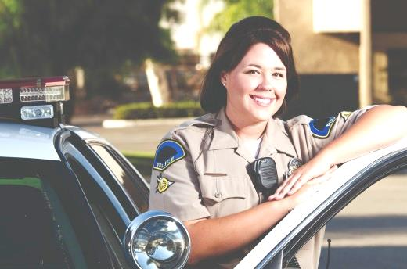

And this is Mrs Hill, a police officer.
Ovo je gospođa Hill, policajka.
She’s wearing her uniform 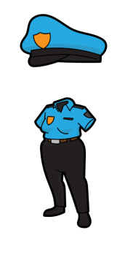because she is on duty.
Ona nosi svoju uniformu jer je na dužnosti (radi).

She’s directing traffic 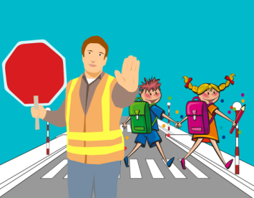.
Ona preusmjerava promet.
The traffic is not heavy.
.Promet nije gust.
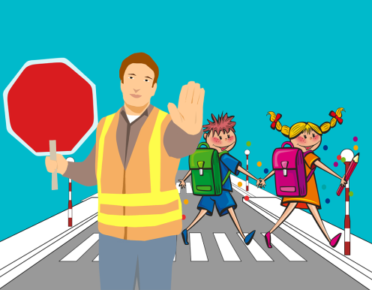
DIRECT TRAFFIC
(usmjeravanje prometa)

So she’s smiling and having fun.
Zato je ona nasmiješena i zabavlja se.

b) Look at the picture.
Read out the word and its meaning.
Pogledaj sličicu. Pročitaj riječ i njezino značenje.
c) Answer the question: What is Mrs Hill doing?
Odgovori na pitanje: Što radi Mrs Hill?
Mrs Hill is _____________________________________ .
* Look for the underlined words in the text.
Potraži podcrtane riječi u tekstu.

d) Read the text once again. Circle the correct answer.
Pročitaj tekst još jednom. Zaokruži točan odgovor.

1 Is Mrs Hill smiling?
Smije li se gospođa Hill?
Yes she is. / No, she isn't.
Da, smije se. / Ne, ne smije se.
2 Is Mrs Hill directing traffic?
Preusmjerava li gospođa Hill promet?
Yes she is. / No, she isn't.
Da, ona preusmjerava promet. / Ne, ona ne preusmjerava promet.

e) Look at the photo of Mrs Hill.
Tick the correct answer.
Pogledaj sliku gospođe Hill. Stavi kvačicu pored točnog odgovora.

Why is Mrs Hill wearing a uniform?
Zašto gospođa Hill nosi uniformu?

A Mrs Hill is wearing a uniform beacuse she is cold.
Gospođa Hill nosi unformu zato što joj je hladno.

B Mrs Hill is wearing a uniform because she is working.
She is a police officer.
Gospođa Hill nosi unofrmu jer je na poslu. Ona radi kao policajac.

f) Copy the answer from task 4 d).
Prepiši odgovor iz zadataka 4 d) na prazne crte.

_____________________________________________
_____________________________________________

- 5 a) Listen to your teacher read the text.
Circle the word in orange.
Poslušaj učitelja kako čita tekst. Zaokruži riječ u narančastom.
COLLIN 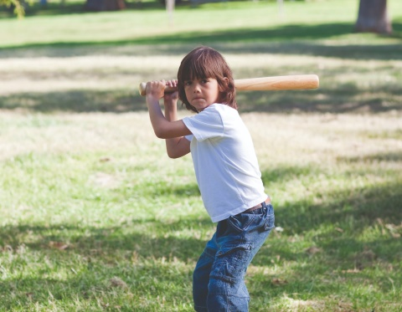
This is Collin, my next-door neighbour.
Ovo je Collin, moj prvi susjed.
He is a little boy who is crazy about baseball.
On je mali dječak koji je lud za bejzbolom.

In this photo he is wearing a white t-shirt.
Na ovoj slici on nosi bijelu majicu kratkih rukava.

He’s playing a game with his friends.
On igra bejzbol za svojim prijateljima.

b) Look at the picture. Read out the word and its meaning.
Pogledaj sličicu. Pročitaj riječ i njezino značenje.


NEXT-DOOR NEIGHBOUR
(prvi susjed)

c) Answer the question: What is Collin doing?
Odgovori na pitanje: Što radi Collin?
Collin is _____________________________________ .
* Look for the underlined words in the text.
Potraži podcrtane riječi u tekstu.

d) Read the text once again.
Circle the correct answer to the question.
Pročitaj tekst još jednom. Zaokruži točan odgovor.

1 Is Collin interviewing Mrs Hill?
Intervjiura li Collin gospođu Smith?
Yes he is. / No, he isn't.
Da, intevjuria. / Ne, ne intervjuira.
2 Is Collin playing baseball with his friends?
Igra li Collin bejzbol sa svojim prijateljima?
Yes he is. / No, he isn't.
Da, igra. / Ne, ne igra.

e) Look at the photo of Collin. Tick the correct answer.
Pogledaj Collinovu sliku. Stavi kvačicu pored točnog odgovora.
Why is Collin hitting a ball?
Zašto Collin udara lopticu?

A Collin is hitting a ball because he is angry.
Collin udara lopticu jer je ljut.

B Collin is hitting a ball because he is playing basketball
with his friends. He is mad about baseball.
Collin udara lopticu jer igra bejzbol. On je lud za bejzbolom.

f) Copy the answer from task 5 d).
Prepiši odgovor iz zadataka 5 d) na prazne crte.

_____________________________________________
_____________________________________________

- 6 a) Read the text.
Circle the words in orange.
Pročitaj tekst. Zaokruži riječi u narančastom.
TIM
Hi, I’m Tim. Photography is my hobby. 
Bok, ja sam Tim. Fotografija je moj hobi.

I've got hundreds of photos.
There are so many interesting people in my neighbourhood.
Imam stotine slika.Ima toliko puno zanimljivih ljudi u mom susjedstvu.



b) Look at the picture. Read out the word and its meaning.
Pogledaj sličicu. Pročitaj riječ i njezino značenje.

NEIGHBOURHOOD
(susjedstvo)

c) Answer the question: What is Tim's hobby?
Odgovori na pitanje: Koji je Timov hobi? Čime se bavi?

Tim's hobby is ____________________________________ .
* Look for the underlined words in the text.
Potraži podcrtane riječi u tekstu.

d) Read the text once again. Circle the correct answer to the question. Pročitaj tekst još jednom. Zaokruži točan odgovor.
1 Is Collin's hobby baseball?
Je li Collinov hobi bejzbol?
Yes it is. / No, it isn't.
Da. / Ne, nije.
2 Are there many interesting people in his neighbourhood?
Ima li mnogo zanimljivih ljudi u njegovom susjedstvu?

Yes there are. / No, there aren't.
Da, ima. / Ne, nema.

e) Look at the photo of Tim. Tick the correct answer.
Pogledaj Timovu sliku. Stavi kvačicu pored točnog odgovora.

Why is Tim holding a camera?
Zašto Tim u rukama drži fotoaparat?

A Tim is holding a camera because he is taking photos.
Tim drži fotoaparat jer njome upravo slika.

B Tim is holding a camera because he wants to buy it.
Tim drži foroaparat u rukama jer je želi kupiti.

f) Copy the answer from task 6 d).
Prepiši odgovor iz zadataka 6 d) na prazne crte.
___________________________________________
___________________________________________

A MULTITASKING FAMILY
1 SOPHIE 2 MAY
1 a) Look at the pictures. What is Sophie doing?
What is May doing? Talk to your friend.
Pogledaj slike. Što radi Sophie? Što radi May?

b) Find the endings to the beginnings of the sentences.
Draw a line to connect them.
Pronađi završetak svakoj rečenici. Spoji ih crtom.

1 Sophie A is washing the dishes and
helping with homework.
pere suđe i pomaže oko zadaće.

2 Sophie's mum, May, B is working on her computer.
Sophijina mama, May radi na računalu.

c) Listen to track 5.2. Who is talking?
Circle the correct answers.
Poslušaj snimku 5.2. Tko govori? Zaokruži točna imena.

Noah Sophie May

d) Listen to track 5.2 once again. Who is doing what?
Sort out the sentences. Put M fo May and S for Sophie.

Poslušaj zapis 5.2. još jednom. Tko što radi?
Stavi M pored rečenica koje opisuju što May radi.
Stavi S pored rečenica koje opisuju što Sophie radi.

1 I'm chatting with five friends online.
S
Pričam s prijateljima preko Interneta.

2 I'm washing the dishes.
Perem suđe

3 I'm doing my maths homework for tomorrow.
Pišem zadaću za sutra.Pišem e-mail za posao.

4 I'm writing an email for work.
.Pišem e-mail za posao

5 I'm studying English and listening to music.
Učim engleski i slušam muziku.

6 I'm saving the world in Space Invaders game.
Spašavam svijet u igri Space Invaders.Pomažem Noah oko zadaće.

7 I'm helping Noah with his homework.
Pomažem Noah oko zadaće.

8 I am cleaning up the kitchen.
Čistim kuhinju.

e) Tick the correct sentences.
Stavi kvačicu pored točnih rčenica.

1 Sophie is doing her maths homework.
Sophie piše zadaću iz matematike.

2 Sophie is studying French.
Sophie uči francuski.

3 Sophie isn’t listening to music.
Sophie ne sluša muziku.

4 May is reading an email.
May čita e-mail.

5 May is washing the dishes.
May pere suđe.

f) Correct the sentences from task 1 e).
Ask teacher to help you.
Ispravi rečenice iz zadatka 1 e). Traži učitelja / učiteljicu za pomoć.
1_________________________________________________
2 _________________________________________________
3 _________________________________________________

g) Listen to track 5.3
. Find the endings to the beginnings of the sentences.
Draw a line to connect them.
Poslušaj snimku 5.3 Pronađi završetak svakoj rečenici. Spoji ih crtom.

1 May is playing Space Invaders game.
igra igru Space Invaders.

2 Sophie is asking for help.
traži pomoć / da joj se pomogne.

